**Midterm project proposal**

**Name:** Goose’s inner world鹅的精神世界

**Introduction:**

This is going to be a project showing an inner world of depressed people. I watch the TED presented by Andrew Solomon, who has depression before. *(https://www.youtube.com/watch?v=-eBUcBfkVCo&list=WL&index=1)*

He read a poetry from Emily Dickinson before the presentation, which I will use in my project.

"I felt a Funeral, in my Brain, and Mourners to and fro kept treading -- treading -- till [it seemed] that Sense was breaking through -- And when they all were seated, a Service, like a Drum -- kept beating -- beating -- till I [thought] my Mind was going numb -- And then I heard them lift a Box and creak across my Soul with those same Boots of Lead, again, then Space -- began to toll, As [all] the Heavens were a Bell, and Being, [but] an Ear, and I, and Silence, some strange Race, wrecked, solitary, here -- [And] then a Plank in Reason, broke, and I fell down and down -- and hit a World, at every plunge, and Finished knowing -- then --"

I will visualize his poetry into animation to help people understand depressed people’s mind. I named it Goose’s inner world because I do not want it to be mean to those depressed people. As a result, I use the replacement --“goose”. In Chinese dialect, the translation of goose is “鹅”, which the pronunciation is similar to “我”, which means “I”. Then, it’s like “My inner world”.

In my project, all the characters are shown as geese. They will conduct a funeral scene, which is the inner world of a special “goose”. I want the animation to proceed by clicking the mouse. For example, for “till [it seemed] that Sense was breaking”, I need to click mouse to product a certain amount of bat, then I go to “when they all were seated” scene. If I have time, I hope I can add sounds and voice into it. If I cannot, I will type the poetry under the scene like movie lines.

**Core elements:**

Till now, I have these core elements need to be drawn.

1) the mourners. They have the same characteristics, the same appearance, pace, and they are indifferent.

2) the bats. They will move in the sky to make the atmosphere heavy.

3) the drum. No goose hit it, but it hit itself and kept beating and beating.

4) the coffin and geese who lift it. Four or maybe more geese will lift a coffin, and I will use cos and sin to express the chattering.

5) death knell. There will be four knells in the four corner, and cos/sin will show its chattering, which means it is working now.

6) bell heavens. This bell will be shown in the top of the screen, and still there.

7) ear. Ear means existence and desire the “bell”—the heavens

8)the special goose: a goose with hat

**Process:**

The full process is going to be like this (this is a draft):

I felt a Funeral, in my Brain, and Mourners to and fro kept treading -- treading -- till [it seemed] that Sense was breaking through

(the geese here will move right and left randomly. Then if click the mouse, the bat will appear. When there are 8 or 10 bats, the scene will jump to the next one)

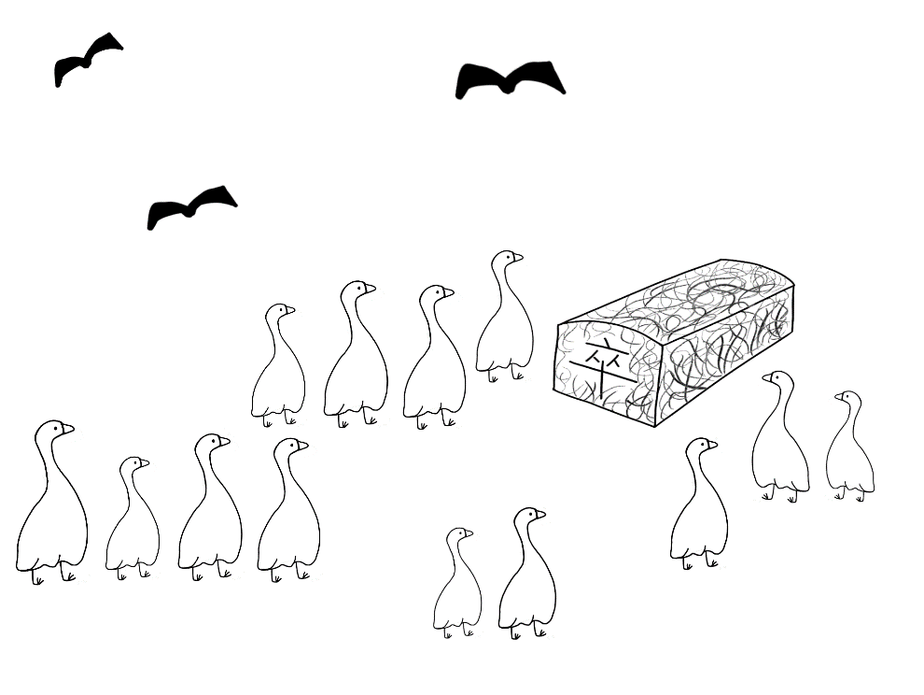

And when they all were seated, a Service, like a Drum -- kept beating -- beating -- till I [thought] my Mind was going numb

(the drum is going to trembling meaning it works. At the beginning, these bats are moving randomly, but later, they become “numb”, which means still)

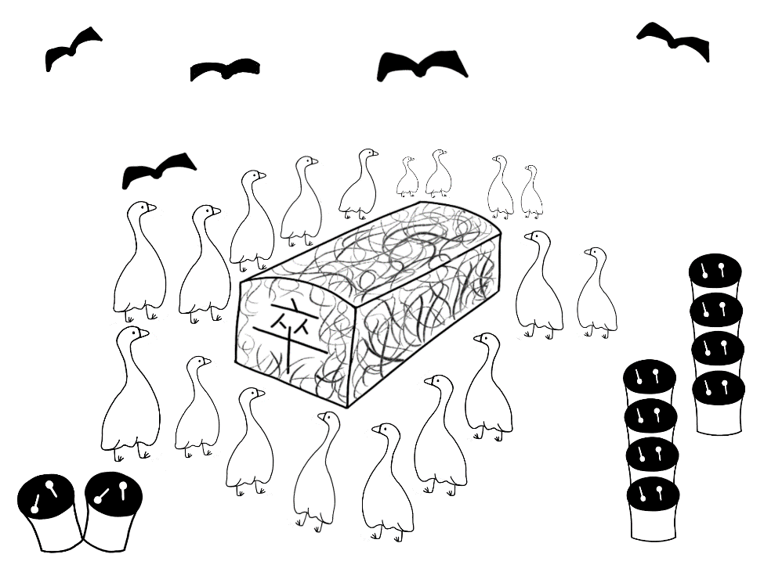

And then I heard them lift a Box and creak across my Soul with those same Boots of Lead,

(the box will be trembling and moved away)上下左右移动，click，box will trembling

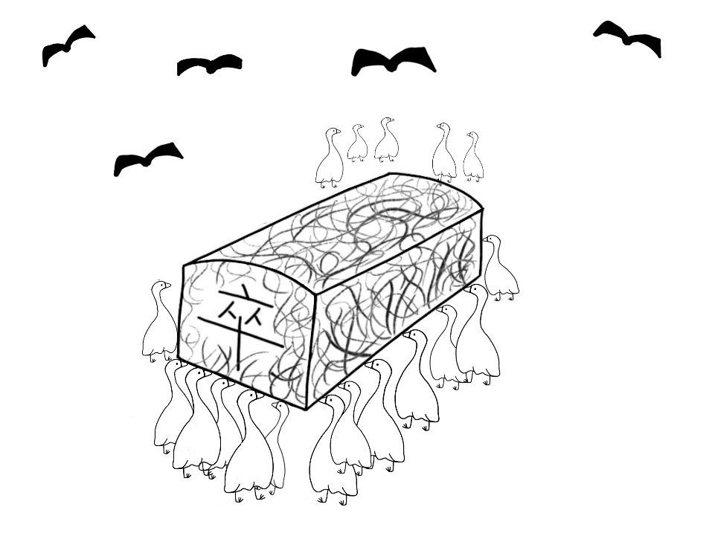

again, then Space -- began to toll, As [all] the Heavens were a Bell, and Being, [but] an Ear,

(the four clocks will tremble but the bell will still at the top of the scene)

Click clock have sounds （耳朵折叠不想听）

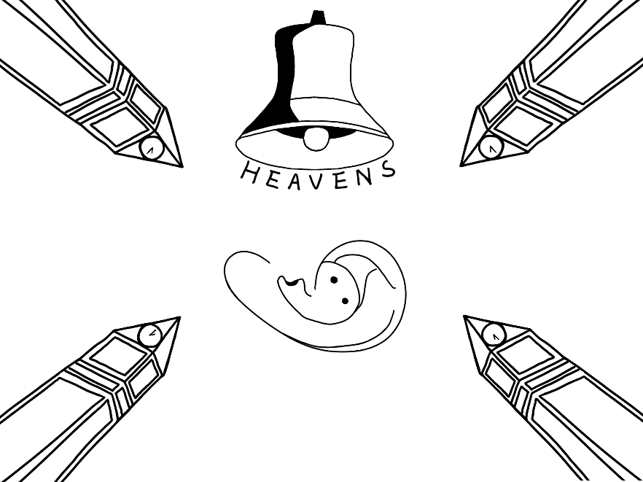

and I, and Silence, some strange Race, wrecked, solitary, here

(the color of the special geese will change, from white to black gradually)

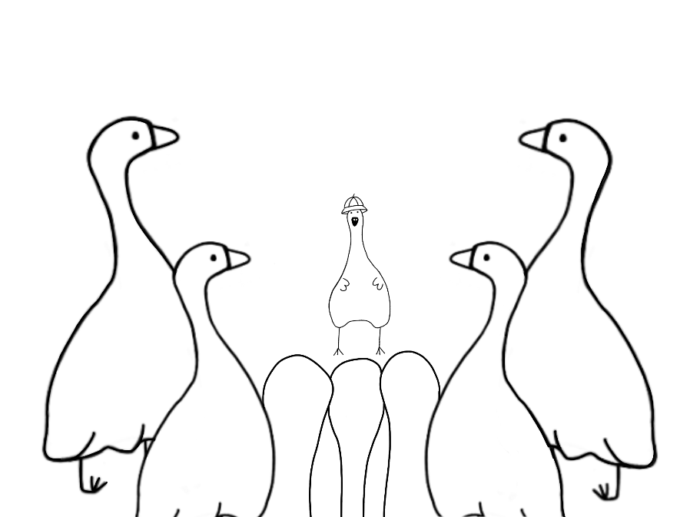

-- [And] then a Plank in Reason, broke, and I fell down and down -- and hit a World, at every plunge, and Finished knowing -- then --"

(here, I will use “bouncing ball” to move the backward little geese, to imitate the “fell down and down”)

Pixel 模糊，从左到右，颜色也变化

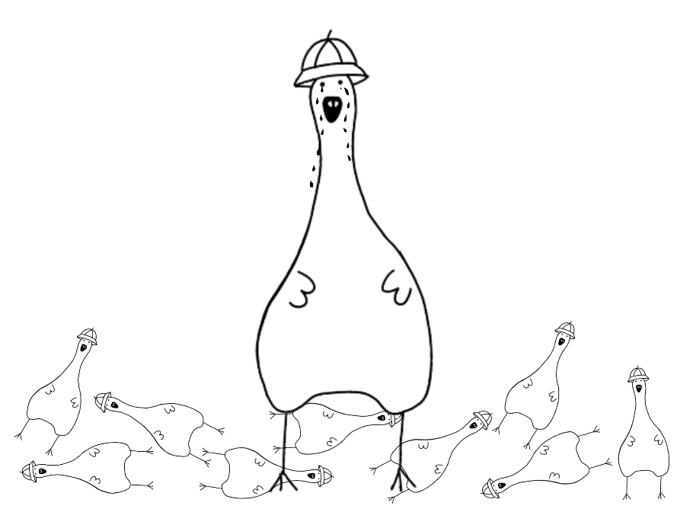

As a result, in general, what I am going to do is making this picture move and interactive.

++放大中间图片，左右用ofbox的andons